**Problem Set 3 (Due 3/20/2025 before class in stapled A4-sized paper)**

**Late homework will NOT be accepted, unless you have notified the course instructor 3 days BEFORE deadline.**

**Part I (60%)**

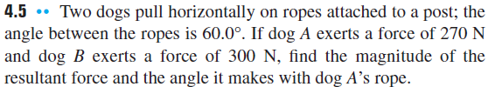

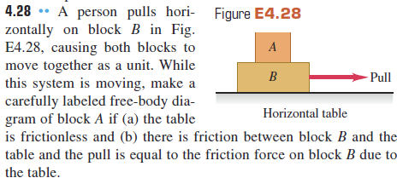

**Part II (40%)**

1. A 1-kg object accelerated at a constant 5 m/s2. Estimate the net force needed to accelerate the object.
2. Object’s mass m = 2 kg, F1 = 5 N, F2 = 3 N. What are the magnitude and direction of the acceleration?

图表

AI 生成的内容可能不正确。

1. Three forces of magnitude 20 N each act on object P as shown below. What is the magnitude and direction of the resultant force? (1.4)

日程表

AI 生成的内容可能不正确。

1. Two forces of magnitudes 15 N and 20 N act at a point on an object. Which one of the following magnitudes CANNOT be the resultant of these forces? (1.5)

表格

AI 生成的内容可能不正确。

1. A 68.5-kg skater moving initially at 2.40 m/s on rough horizontal ice comes to rest uniformly in 3.52 s due to friction from the ice. What force does friction exert on the skater?
2. A box rests on a frozen pond, which serves as a frictionless horizontal surface. If a fisherman applies a horizontal force with magnitude 48.0 N to the box and produces an acceleration of 3.00 m/s2, magnitude what is the mass of the box?

For Problems 7-8: A ball is hanging from a long string that is tied to the ceiling of a train car traveling eastward on horizontal tracks. An observer inside the train car sees the ball hang motionless. Is the net force on the ball zero in either case? Explain.

1. Draw a clearly labeled free-body diagram for the ball if the train has a uniform velocity.
2. Draw a clearly labeled free-body diagram for the ball if the train is speeding up uniformly.

For problem 9-10: A skier of mass 65.0 kg is pulled up a snow-covered slope at constant speed by a tow rope that is parallel to the ground. The ground slopes upward at a constant angle of 26 degrees above the horizontal, and you can ignore friction.

1. Draw a clearly labeled free-body diagram for the skier.
2. Calculate the tension in the tow rope.